**A Private Tour in Alsace & Germany**

Unique opportunity to discover the beautiful region of Alsace

ようこそ！

フランスのアルザス地方

へ

ドイツの文化を色濃く受けた独特な美しい街並みと、山や川に囲まれ雄大な

景観を持つフランスのアルザス地方。

伝統と近代的技術を共存させ「ヨーロッパの十字路」とも称される国際的な

地方都市ストラスブール、ワイン街道、コルマール、お城、山など

…

ワイン街道沿いに小さくてかわいい街々が広がります。

**1**

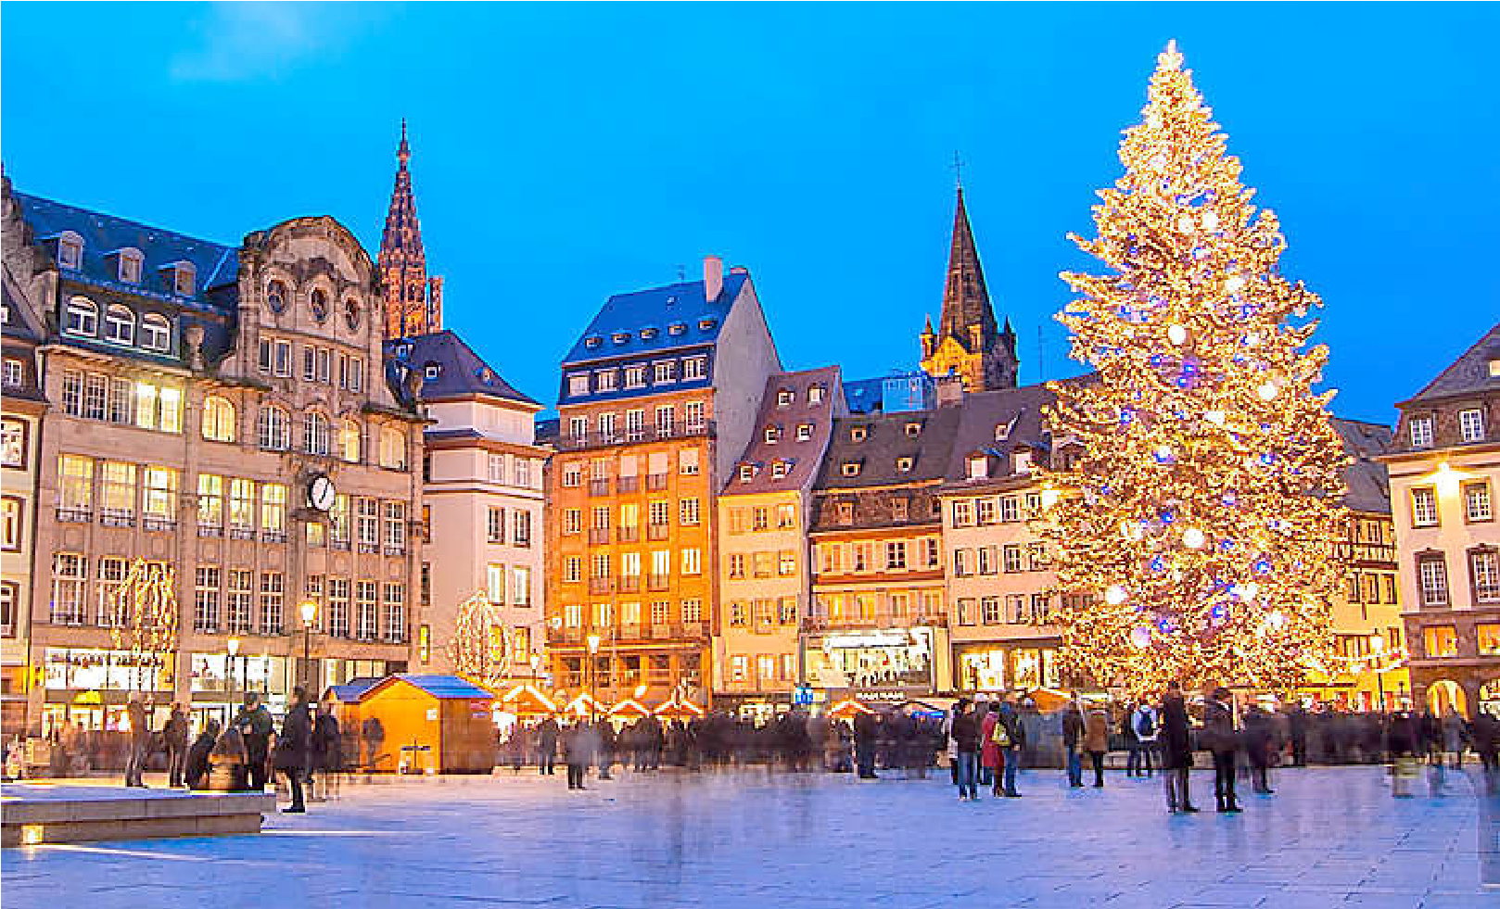

**Christmas in Alsace**

**Discover Alsace, in France**

**and the Black Forest, in Germany**

**PRESENTED BY YOKO MISUMI & MATHIEU MAURICE**

**DECEMBER 2024**



A day trip to the

Black Forest, in

Germany

We will cut our

christmas tree in

the forest to

prepare

Christmas Season.

Flower

Arrangement

Lesson by Yoko

Misumi

Discover the

Beautiful Villages

on the Vine Route

and Taste the

Local Wines

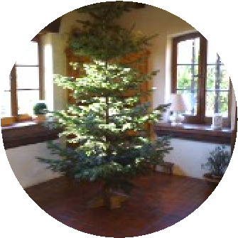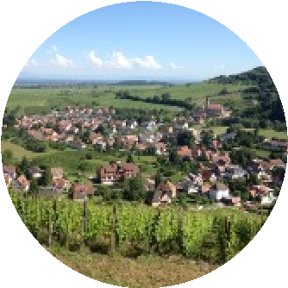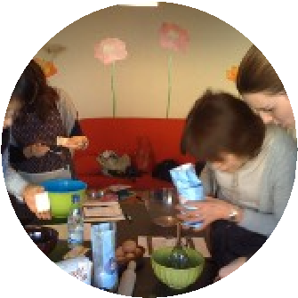

Yoko MISUMI



Mathieu MAURICE

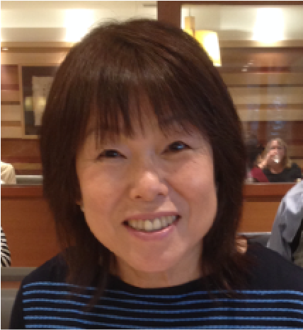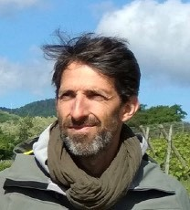

# Day 1

Leave Japan

Arrive at hotel in Alsace

# Day 2

Visit of Strasbourg and the oldest Christmas Market (since the 15th Century)

Strasbourg's historic city centre, the [*Grande Île*](https://en.wikipedia.org/wiki/Grande_%C3%8Ele_%28Strasbourg%29) (Grand Island), was classified a [World Heritage site](https://en.wikipedia.org/wiki/World_Heritage_Site) by [UNESCO](https://en.wikipedia.org/wiki/UNESCO) in 1988, the first time such an honour was placed on an entire city centre.

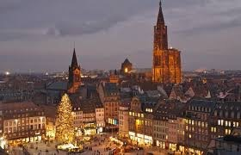

# Day 3

Visit of the Wine Route and its beautiful villages:

Riquewhir, Kaysersberg…

Wine tasting (Alsace is famous for its great quality white wines (Riesling, Pinot Gris, Gewürztraminer…) Taste and discover the particularities of the typical alsatian wines.

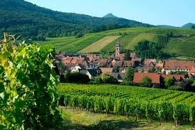

# Day 4

A day in the Black Forest (Schwartzwald). Crossing the Rhine River by car, we will explore the Black Forrest and its beautiful villages/towns:

Gengenbach, and Durbach, where we will cut our

Christmas Tree ourselves and Prepare it for

Christmas Season.

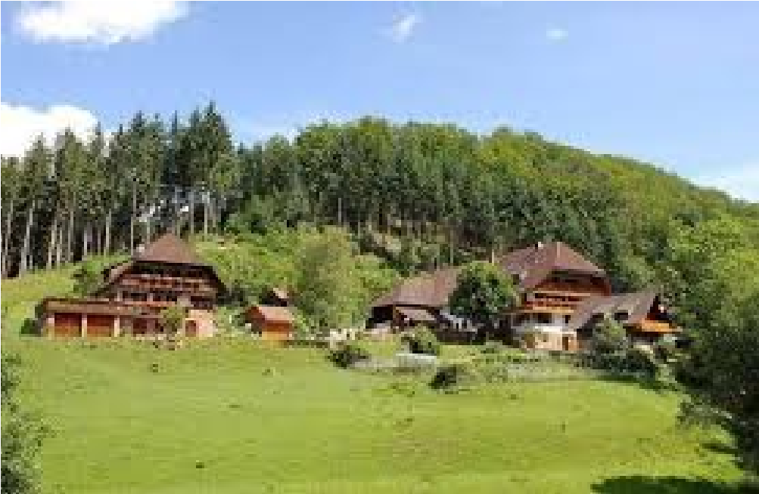

# Day 5

Visit of Colmar (the Wine Capital of Alsace and hometown of Bartholdi; the sculptor of the Statue of

Liberty in New York, and of the Alsacian painter

« Hansi »)

# Day 6

Flower Arrangement Lesson with Yoko Misumi and French guests (an opportunity to exchange with local people from Alsace)

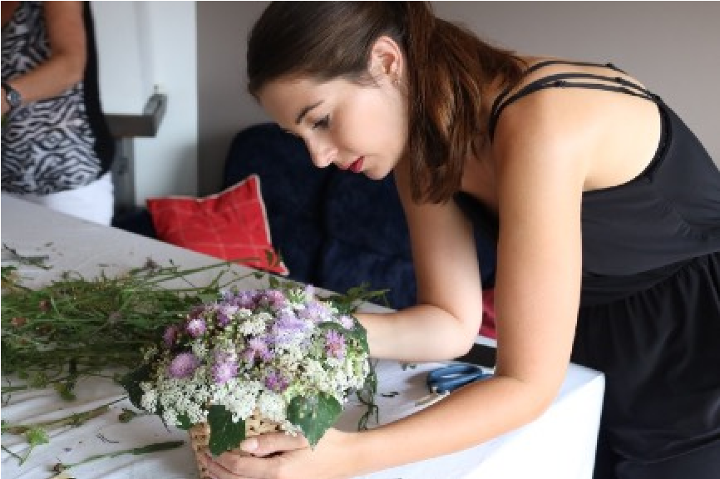

# Day 7

Visit of the village of Eguisheim, and lunch in a Mountain Restaurant (typical dish made with local products; cheese, meat…)

Visit the original shop of Christine Ferber (the famous Jam Maker from Alsace) in the village of

Niedermorshwihr.

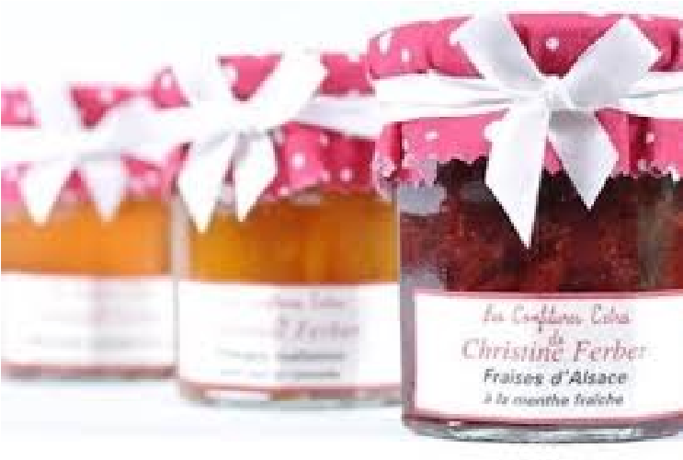

# Day 8

Departure from the hotel.

Visit on the way to the Airport of Frankfurt

Flight back to Japan

# Day 9

Arrive in Japan

**2**